|  |
| --- |
| **INDIAN RESORTS BOOKING SYSTEM** |

**_____________________________________**

Report by-

|  |  |
| --- | --- |
| Project no: | Group no: |

|  |  |  |  |
| --- | --- | --- | --- |
| Name: | Regd_no: | Roll no: | Section: |

|  |  |  |  |
| --- | --- | --- | --- |
| M.Ajay | 12103197 | RK21BEA18 | K21BE |

Description of work of each member:

This complete project is made by myself.

Home:

❑ It is Home page of our Website.

❑ From here any one can book your resorts in online.

❑ Tag Used : html , head , link , style , body , div ,

Img, a , label , input , select , ul, li, option , h1, header.

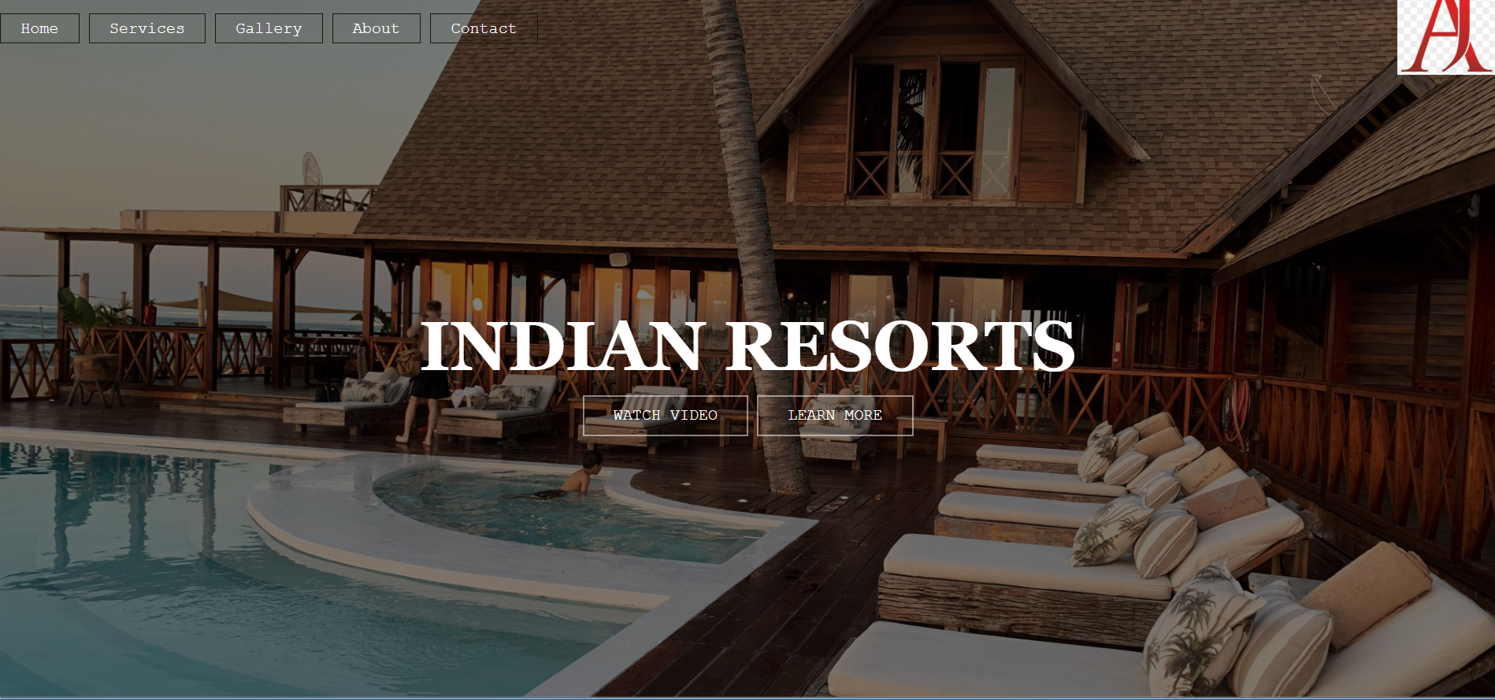

About us:

❑ From here you can check our offers details, deals, facilities .

❑ Tag Used : html , head , link , style , h2 , h3 ,

br, p1, p2, p3, body , div , img , input , button.

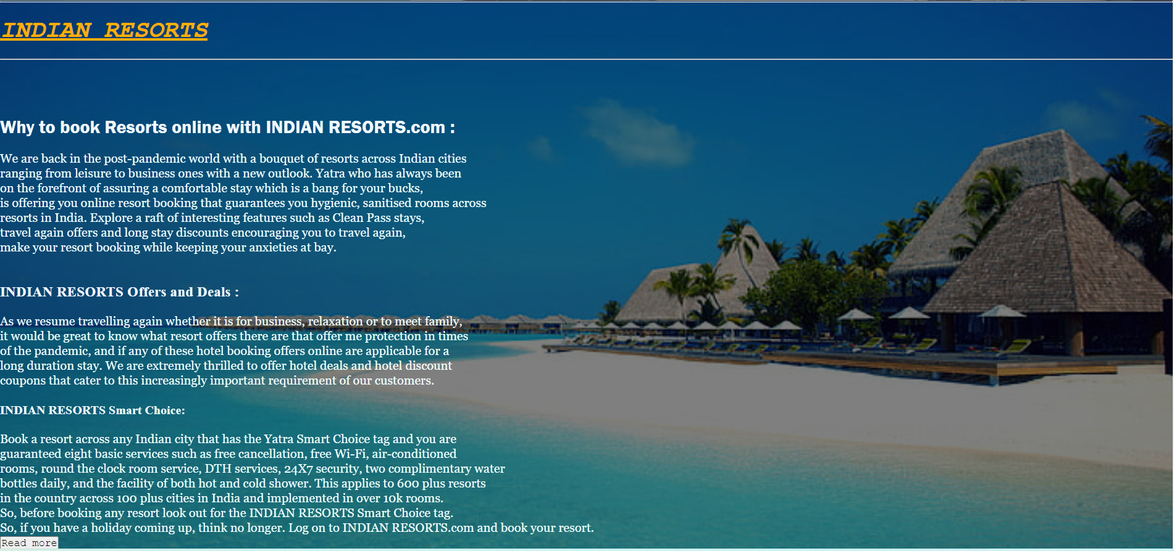

Review of resorts :

❑ From here you can slide the images of resorts around India.

❑ Tags used : html, div, script, nextBtn, prevBtn, document.queryselector, document.querryselectorall,

document.addEventListener, img.

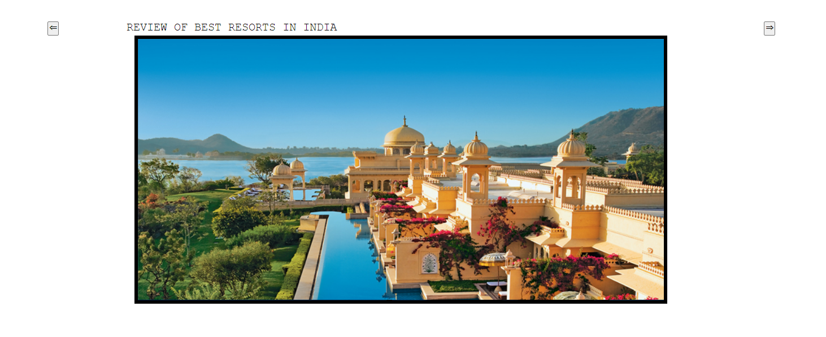

Contact us:

❑ From here you can submit your registration

in a particular date and day of your choice.

❑ Tags used : html, head, div, center, img, label, input, H5, h6, h7, h8, h9, h10, button.

